

Client Consultation Form
iUSP149 – Sports massage

Centre name:
Centre number:
Learner name:
Learner number:
Date:

Client name:
Address:
Profession:
Telephone number: | Day:
Telephone number: | Evening:

Personal details:
Age group: | Under 20 ☐ | 20 – 30 ☐ | 30 – 40 ☐ | 40 – 50 ☐ | 50 – 60 ☐ | 60+ ☐
Lifestyle: | Active ☐ |  |  | Sedentary ☐
Last visit to the doctor:
GP Address:
Number of children:
(If applicable)
Date of last period:
(If applicable)

Contra-indications requiring medical permission – Never treat unless the injury has been diagnosed and treatment has been recommended by a medical practitioner.
Pregnancy | ☐ | Cardio vascular conditions (thrombosis, phlebitis, hypertension, hypotension, heart conditions) | ☐ | Haemophilia | ☐
Any condition already being treated by a GP or another health professional, e.g. physiotherapist, osteopath, chiropractor or coach | ☐ | Medical oedema | ☐ | Osteoporosis | ☐
Arthritis | ☐ | Nervous/Psychotic conditions | ☐ | Epilepsy | ☐
Recent operations | ☐ | Diabetes | ☐ | Asthma | ☐
Any dysfunction of the nervous system (e.g. Multiple sclerosis, Parkinson’s disease, Motor neurone disease) | ☐ | Bell’s palsy | ☐ | Trapped/pinched nerve  (e.g. sciatica) | ☐
Inflamed nerve | ☐ | Cancer | ☐ | Postural deformities | ☐
Spastic conditions | ☐ | Kidney infections | ☐ | Whiplash | ☐
Slipped disc | ☐ | Undiagnosed pain | ☐ | When taking prescribed medication | ☐
Acute rheumatism | ☐

Contra-indications that restrict treatment – (Select if/where appropriate):
Fever | ☐ | Contagious or  infectious diseases | ☐ | Under the influence of recreational drugs or alcohol | ☐
Diarrhoea and vomiting | ☐ | Skin diseases | ☐ | Undiagnosed lumps and bumps | ☐
Localised swelling | ☐ | Inflammation | ☐ | Varicose veins | ☐
Pregnancy (abdomen) | ☐ | Cuts | ☐ | Bruises | ☐
Abrasions | ☐ | Scar tissues (2 years for major operation and 6 months for a small scar) | ☐ | Sunburn | ☐
Hormonal implants | ☐ | Abdomen (first few days of menstruation depending how the client feels) | ☐ | Haematoma | ☐
Hernia | ☐ | Recent fractures  (minimum 3 months) | ☐ | Cervical spondylitis | ☐
Gastric ulcers | ☐ | After a heavy meal | ☐

Written permission required by GP/SPECIALIST:
Which should be attached to the consultation form
GP/Specialist | ☐ | Informed consent | ☐

Personal information – (Select if/where appropriate):
Muscular/Skeletal problems: | Back | ☐ | Aches/Pain | ☐ | Stiff joints | ☐ |  | Headaches |  | ☐
Digestive problems: | Constipation | ☐ | Bloating | ☐ | Liver/Gall bladder | ☐ |  | Stomach |  | ☐
Circulation: | Heart | ☐ | Blood pressure | ☐ | Fluid retention | ☐ |  | Tired legs |  | ☐
Circulation: | Varicose veins | ☐ | Cellulite | ☐ | Kidney problems | ☐ |  | Cold hands and feet |  | ☐
Gynaecological: | Irregular periods | ☐ | P.M.T | ☐ | Menopause | ☐ |  | H.R.T |  | ☐
Gynaecological: | Pill | ☐ | Coil | ☐ | Other:
Nervous system: | Migraine | ☐ | Tension | ☐ | Stress | ☐ |  | Depression |  | ☐
Immune system: | Prone to infections | ☐ | Sore throats | ☐ | Colds | ☐ |  | Chest |  | ☐
Immune system: | Sinuses | ☐
Regular antibiotic/medication taken?
If yes, which ones: |  |  |  |  |  |  | Yes ☐ |  | No ☐
Herbal remedies taken?
If yes, which ones: |  |  |  |  |  |  | Yes ☐ |  | No ☐
Ability to relax: | Good | ☐ | Moderate | ☐ | Poor | ☐
Sleep patterns: | Good | ☐ | Poor | ☐ | Average no. of hours:
Do you see natural daylight in your workplace? | Yes | ☐ | No | ☐
Do you work at a computer? | Yes | ☐ | No | ☐ | If yes how many hours:
Do you eat regular meals? | Yes | ☐ | No | ☐
Do you eat in a hurry? | Yes | ☐ | No | ☐
Do you take any food/vitamin supplements? | Yes | ☐ | No | ☐ | If yes, which ones:
How many portions of each of these items does your diet contain per day? | Fresh fruit: |  | Fresh vegetables: |  | Protein: |  |  | Source:
 | Dairy produce: |  | Sweet things: |  | Added salt: |  |  | Added sugar:

How many units of these drinks do you consume per day? | Tea: |  | Coffee: |  | Fruit juice: |  | Water:
How many units of these drinks do you consume per day? | Soft drinks: |  | Other:
Do you suffer from food allergies? | Yes | ☐ | No | ☐
Bingeing | Yes | ☐ | No | ☐
Overeating | Yes | ☐ | No | ☐
Do you smoke? | Yes | ☐ | No | ☐ | How many per day:
Do you drink alcohol? | Yes | ☐ | No | ☐ | How many units per day:
Do you exercise? | None | ☐ | Occasional | ☐ | Irregular | ☐ | Regular | ☐
Do you exercise? | Type:
What is your skin type? | Dry | ☐ | Oily | ☐ | Combination | ☐ | Dehydrated | ☐
Do you suffer/  have you suffered from: | Dermatitis | ☐ | Acne | ☐ | Eczema | ☐ | Psoriasis | ☐
Do you suffer/  have you suffered from: | Allergies | ☐ | Hay fever | ☐ | Asthma | ☐ | Skin cancer | ☐
Stress level:  1–10 (10 being the highest) | At work: |  |  |  | At home:

Physical examination:
Head:
Shoulders:
Back:
Pelvis:
Legs:
Feet:
Body alignment/
posture:
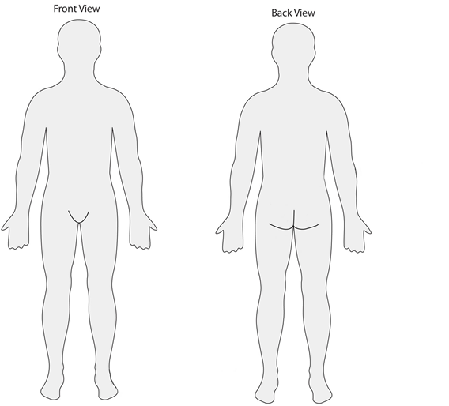

Assessment:
Rationale for treatment:
Treatment:
How the client felt during the treatment:
How the client felt after the treatment:
Home care advice given:
Reflective practice:

Therapist/learner signature: _______________________________________________________________________

Client signature: _________________________________________________________________________________

iUSP149 – Follow-up sheet
Assessment:
Rationale for treatment:
Treatment:
How the client felt during the treatment:
How the client felt after the treatment:
Home care advice given:
Reflective practice:
Date of treatment:

iUSP149 – Follow-up sheet
Assessment:
Rationale for treatment:
Treatment:
How the client felt during the treatment:
How the client felt after the treatment:
Home care advice given:
Reflective practice:
Overall conclusion:

Date of treatment: _______________________________________________________________________________
Document History
Version | Issue Date | Changes | Role
v1 | 27/09/2019 | First published | Qualifications Administrator

