

Treatment evidence Form

iUBT334 – Reflexology
Centre name:
Centre number:
Learner name:
Learner number:
Date:

Client name:
Address:
Profession:
Telephone number: | Day:
Telephone number: | Evening:

Personal details:
Age group: | Under 20 ☐ | 20 – 30 ☐ | 30 – 40 ☐ | 40 – 50 ☐ | 50 – 60 ☐ | 60+ ☐
Lifestyle: | Active ☐ |  |  | Sedentary ☐
Last visit to the doctor:
GP Address:
Number of children:
(If applicable)
Date of last period:
(If applicable)

Contra-indications requiring medical permission – in circumstances where medical permission cannot be obtained clients must give their informed consent in writing prior to treatment (select if/where appropriate):
Pregnancy | ☐ | Cardiovascular condition (thrombosis, phlebitis, hypertension, hypotension, heart conditions) | ☐ | Any condition already being treated by a GP or another complementary practitioner | ☐
Medical oedema | ☐ | Osteoporosis | ☐ | Arthritis | ☐
Nervous/psychotic conditions | ☐ | Epilepsy | ☐ | Recent operations | ☐
Diabetes | ☐ | Asthma | ☐ | Any dysfunction of the nervous system (e.g. multiple sclerosis, Parkinson’s disease, motor neurone disease) | ☐
Trapped/pinched nerve (e.g. sciatica) | ☐ | Inflamed nerve | ☐ | Cancer | ☐
Conditions causing muscular spasticity (e.g. cerebral palsy) | ☐ | Kidney infections | ☐ | Acute rheumatism | ☐

Contra-indications that restrict treatment (select if/where appropriate):
Fever | ☐ | Contagious or  infectious diseases | ☐ | Under the influence of recreational drugs or alcohol | ☐
Diarrhoea and vomiting | ☐ | Pregnancy (first trimester) | ☐ | Skin diseases | ☐
Localised swelling | ☐ | Inflammation | ☐ | Varicose veins | ☐
Cuts | ☐ | Bruises | ☐ | Abrasions | ☐
Scar tissues (2 years for  major operations and 6 months for a small scar) | ☐ | Sunburn | ☐ | Haematoma | ☐
Recent fractures  (minimum 3 months) | ☐ | Slipped disc | ☐

Written permission required by (either of which should be attached to the consultation form):
GP/specialist ☐ | Informed consent ☐

Personal information (select if/where appropriate):
Muscular/skeletal problems: | Back |  |  | ☐ | Aches/pain |  |  |  |  |  |  | ☐ | Stiff joints |  |  |  |  |  |  |  |  | ☐ | Headaches |  | ☐
Digestive problems: | Constipation |  |  | ☐ | Bloating |  |  |  |  |  |  | ☐ | Liver/Gall bladder |  |  |  |  |  |  |  |  | ☐ | Stomach |  | ☐
Circulation: | Heart |  |  | ☐ | Blood pressure |  |  |  |  |  |  | ☐ | Fluid retention |  |  |  |  |  |  |  |  | ☐ | Tired legs |  | ☐
Circulation: | Varicose veins |  |  | ☐ | Cellulite |  |  |  |  |  |  | ☐ | Kidney problems |  |  |  |  |  |  |  |  | ☐ | Cold hands and feet |  | ☐
Gynaecological: | Irregular periods |  |  | ☐ | P.M.T |  |  |  |  |  |  | ☐ | Menopause |  |  |  |  |  |  |  |  | ☐ | H.R.T |  | ☐
Gynaecological: | Pill |  |  | ☐ | Coil |  |  |  |  |  |  | ☐ | Other |  |  |  |  |  |  |  |  |  |  |  | ☐
Nervous system: | Migraine |  |  | ☐ | Tension |  |  |  |  |  |  | ☐ | Stress |  |  |  |  |  |  |  |  | ☐ | Depression |  | ☐
Immune system: | Prone to infections |  |  |  | ☐ |  | Sore throats |  |  |  |  |  |  |  | ☐ |  | Colds |  |  |  |  |  |  |  | ☐
Immune system: | Sinuses |  |  |  |  |  |  |  |  |  |  | ☐ | Chest |  |  |  |  |  |  |  |  |  |  |  | ☐
Regular  antibiotic/  medication taken? | Yes |  |  | ☐ | No |  |  |  |  |  |  | ☐ | If yes, which ones?
Herbal remedies taken? | Yes |  |  | ☐ | No |  |  |  |  |  |  | ☐ | If yes, which ones?
Ability to relax: | Good |  |  |  |  | ☐ |  |  | Moderate |  |  |  |  |  |  |  |  | ☐ |  | Poor |  |  |  |  | ☐
Sleep patterns: | Good |  |  | ☐ | Poor |  |  |  |  |  |  | ☐ | Average no. of hours:
Do you see natural daylight in your workplace? | Yes |  |  |  |  |  |  |  |  |  |  | ☐ | No |  |  |  |  |  |  |  |  |  |  |  | ☐
Do you work at a computer? | Yes |  |  | ☐ | No |  |  |  |  |  |  | ☐ | If yes, how many hours?
Do you eat regular meals? | Yes |  |  |  |  |  |  |  |  |  |  | ☐ | No |  |  |  |  |  |  |  |  |  |  |  | ☐
Do you eat in a hurry? | Yes |  |  |  |  |  |  |  |  |  |  | ☐ | No |  |  |  |  |  |  |  |  |  |  |  | ☐
Do you take any food/vitamin supplements? | Yes |  |  | ☐ | No |  |  |  |  |  |  | ☐ | If so, which ones?
How many portions of each of these items does your diet contain per day? | Fresh fruit: |  |  |  | Fresh vegetables: |  |  |  |  |  |  |  | Protein and source:
 | Dairy produce: |  |  |  | Sweet things: |  |  |  |  |  |  |  | Added salt: |  |  |  |  |  |  |  |  |  | Added sugar:
How many units of these drinks do you consume per day? | Tea: |  |  |  | Coffee: |  |  |  |  |  |  |  | Fruit juice: |  |  |  |  |  |  |  |  |  | Water:
How many units of these drinks do you consume per day? | Soft drinks: |  |  |  | Others:
Do you suffer from food allergies? | Yes |  |  |  |  |  |  |  |  |  |  | ☐ | No |  |  |  |  |  |  |  |  |  |  |  | ☐
Bingeing? | Yes |  |  |  |  |  |  |  |  |  |  | ☐ | No |  |  |  |  |  |  |  |  |  |  |  | ☐
Overeating? | Yes |  |  |  |  |  |  |  |  |  |  | ☐ | No |  |  |  |  |  |  |  |  |  |  |  | ☐
Do you smoke? | Yes |  |  |  |  |  |  |  | ☐ |  | No |  |  |  |  |  |  |  | ☐ |  | How many a day?
Do you drink alcohol? | Yes |  |  |  |  |  |  |  | ☐ |  | No |  |  |  |  |  |  |  | ☐ |  | How many units a day?
Do you exercise? | None |  |  | ☐ | Occasional |  |  |  |  |  |  | ☐ | Irregular |  |  |  |  |  |  |  |  | ☐ | Regular |  | ☐
Do you exercise? | Types:
What is your skin type? | Dry | ☐ | Oily |  |  |  |  | ☐ |  | Combination |  |  |  | ☐ |  | Sensitive |  |  |  |  |  |  | ☐ | Dehydrated | ☐
Do you suffer/have you suffered from | Dermatitis |  |  | ☐ | Acne |  |  |  |  |  |  | ☐ | Eczema |  |  |  |  |  |  |  |  | ☐ | Psoriasis |  | ☐
Do you suffer/have you suffered from | Allergies |  |  | ☐ | Hay Fever |  |  |  |  |  |  | ☐ | Asthma |  |  |  |  |  |  |  |  | ☐ | Skin cancer |  | ☐
Stress level 1–10 (10 being the highest): | At work: |  |  |  |  |  |  |  |  |  |  |  | At home:
Reasons for treatment:

Reading of the feet:
Texture:
Areas of swelling/
puffiness:
Shape of feet/toes:
Alignment of feet:
Temperature:
Colour:
Smell:
Tone:
Mobility/
flexibility:
Skeletal deformities:
Condition of the nails:

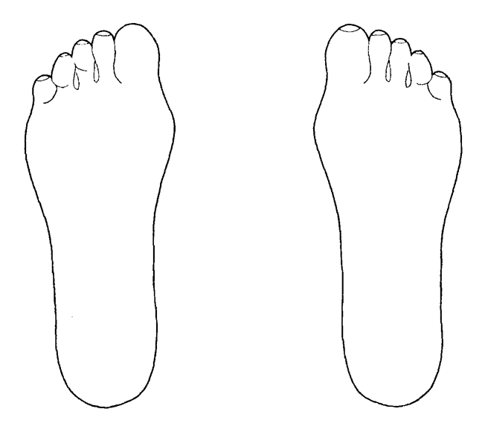

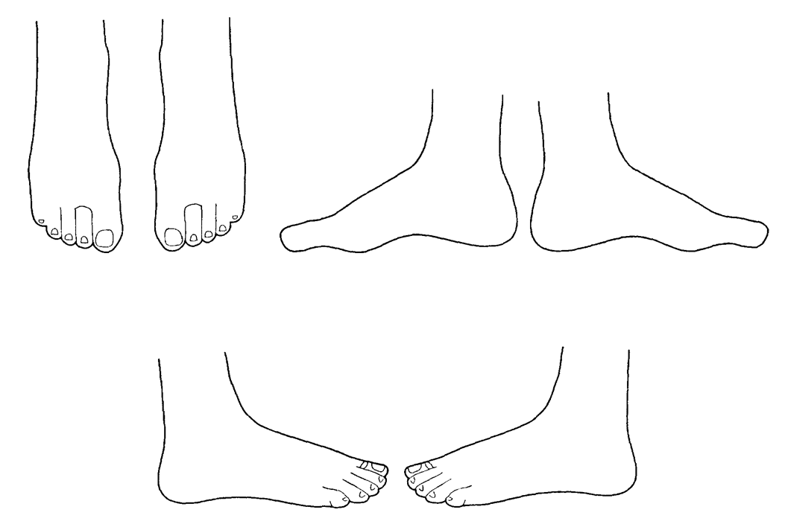
Client profile:
Treatment plan:
Details of how the therapist conducted the treatment:
How the client felt before the treatment:
How the client felt during the treatment:
How the client felt immediately after the treatment and immediate aftercare given:
Specific homecare advice given:
Recommendations for self-treatment:
Reflective practice:
Overall conclusion:

Therapist/Learner signature: _______________________________________________________________________
Client signature: _________________________________________________________________________________

iUBT334 – Follow-up Sheet

Reading of the feet:
Texture:
Areas of swelling/ puffiness:
Shape of feet/toes:
Alignment of feet:
Temperature:
Colour:
Smell:
Tone:
Mobility/ flexibility:
Skeletal deformities:
Condition of the nails:

Client profile:
Treatment plan:
Details of how the therapist conducted the treatment:
How the client felt before the treatment:
How the client felt during the treatment:
How the client felt immediately after the treatment and immediate aftercare given:
Specific homecare advice given:
Recommendations for self-treatment:
Reflective practice:
Overall conclusion:

Learner signature: _______________________________________________________________________________
Client signature: _________________________________________________________________________________

Document History
Version | Issue Date | Changes | Role
v1 | 09/10/19 | First published | Qualifications Administrator
v2 | 17/12/19 | Format corrections | Qualifications Administrator
v3 | 14/01/2020 | Amended consultation to treatment evidence | Qualifications and Regulation Co-ordinator

