

Clinical Case Study Form
UBT277 – Provide Radio Frequency Treatment

Centre name:
Centre number:
Learner name:
Learner number:
Date:

Client name:
Address:
Profession:
Telephone number: | Day:
Telephone number: | Evening:

Personal details:
Age group: | Under 20 ☐ | 20 – 30 ☐ | 30 – 40 ☐ | 40 – 50 ☐ | 50 – 60 ☐ | 60+ ☐
Occupation:
Lifestyle: | Active ☐ |  |  | Sedentary ☐
Details of activity:
GP Address:

Contra-indications that prevent treatment – (Select if/where appropriate):
Acne | ☐ | Active infection – bacterial, viral, fungal, herpetic | ☐ | Active inflammation | ☐
Anticoagulant medication | ☐ | Autoimmune conditions | ☐ | Cancer | ☐
Contagious skin diseases | ☐ | Degenerative  neurological disorders | ☐ | Diabetes | ☐
Diseases stimulated by heat | ☐ | Dysfunctions of  the nervous system | ☐ | Heart disease/disorder | ☐
Inflammations/infection in treatment area | ☐ | Internal defibrillator | ☐ | Impaired kidney function | ☐
Impaired liver function | ☐ | IVF procedure | ☐ | Keloid scarring | ☐
Lactation | ☐ | Metal implants in  treatment area (excluding dental implants) | ☐ | Pacemaker | ☐
Photosensitising medication | ☐ | Pregnancy | ☐ | Recent scar tissue | ☐
Recent skin peeling | ☐ | Recurrent Herpes Simplex in treatment area | ☐ | Rosacea in treatment area | ☐
Roaccutane use | ☐ | Steroidal medication | ☐ | Swelling in treatment area | ☐
Thrombosis | ☐ | Thrombophlebitis | ☐ | Thyroid disorders | ☐
Undiagnosed lumps | ☐ | Varicose veins | ☐
Comments:

Contra-indications that restrict treatment – (Select if/where appropriate):
Abrasions | ☐ | Botulinum injection/  dermal fillers | ☐ | Bruises | ☐
Cosmetic skin needling | ☐ | Cuts | ☐ | Crystal microdermabrasion | ☐
Epilation treatment | ☐ | Excessively oily skin | ☐ | Herpes simplex | ☐
IPL treatment | ☐ | Large moles | ☐ | Laser treatment | ☐
Metal prostheses/implants | ☐ | Loss of skin sensitivity | ☐ | Microdermabrasion treatment | ☐
Prior to cosmetic surgery | ☐ | Recent chemical peel | ☐ | Recent scars/wounds | ☐
Sensitive/reactive skin type | ☐ | Silicone implants | ☐ | Telangiectasia | ☐
UV exposure | ☐ | Varicose veins | ☐
Comments:

General:
Active inflammatory dermatoses | ☐ | Anxiety | ☐ | Circulatory disorders | ☐
Current medications | ☐ | Epilepsy | ☐ | Herbal remedies/supplements | ☐
Implants/IUDs | ☐ | Isotretinoin use | ☐ | Poor mental/emotional state | ☐
Over thyroid gland | ☐ | Piercings | ☐ | Recent surgery | ☐
Rosacea (depending  on area affected) | ☐ | Scars in treatment area | ☐
Comments:

Written permission required by:
Either of which should be attached to the treatment form
GP/Specialist ☐ | Informed consent ☐

Personal information – (Select if/where appropriate):
Have you had any health problems in the past or present?
If yes, please specify: | Yes ☐ | No ☐
Have you been under the care of a medical practitioner or other healthcare specialist in the last year?
If yes, please specify: | Yes ☐ | No ☐
Are you currently using any prescription medications (oral or topical)?
If yes, please specify: | Yes ☐ | No ☐
Are you currently using any supplements or herbal remedies (oral or topical)?
If yes, please specify: | Yes ☐ | No ☐
Do you suffer from anxiety, stress, depression and/or are clinically diagnosed?
If yes, please specify: | Yes ☐ | No ☐
What are your stress levels?  1 to 10 (10 being the highest) | At work: | At home:
Do you smoke?
If yes, how many per day? | Yes ☐ | No ☐
Do you drink alcohol?
If yes, how many units per week? | Yes ☐ | No ☐

Are you trying to conceive, pregnant or lactating?
If yes, please specify: |  |  |  |  | Yes ☐ | No ☐
Are you:
Due or having your  menstrual period | ☐ | Peri-menopausal | ☐ | Menopausal |  |  | ☐
Additional details:

Do you have any allergies?
If yes, please provide details: | Yes ☐ | No ☐
What is your level of sun exposure?
Please specify details:

Are you currently sun/wind burnt? | Yes ☐ | No ☐
Do you wear a sun protectant?
If yes, please specify SPF/frequency of application: | Yes ☐ | No ☐
Do you suffer from Herpes simplex?
If yes, please specify where outbreaks occur/frequency: | Yes ☐ | No ☐

Have you had any of the following within the last 14 days?
Botox/injectable dermal fillers | Yes ☐ | No ☐ | Light based therapy | Yes ☐ | No ☐
Depilatory treatments | Yes ☐ | No ☐ | Laser | Yes ☐ | No ☐
Electrolysis | Yes ☐ | No ☐ | Microdermabrasion | Yes ☐ | No ☐
Facial surgery | Yes ☐ | No ☐ | Skin needling | Yes ☐ | No ☐
IPL | Yes ☐ | No ☐ | Skin peeling | Yes ☐ | No ☐
If yes, please specify treatment details (to include treatment dates, frequency, results and client satisfaction with outcome):

Do you use Retin A or any other prescription skin care products?
If yes, please specify details: | Yes ☐ | No ☐
Have you taken/used Isotretinoin within the last 6-12 months?
If yes, please specify details: | Yes ☐ | No ☐

Do you use home care products containing any of the following?
Exfoliating granules | ☐ | Glycolic Acid | ☐ | Lactic Acid | ☐
Other Alpha Hydroxy Acids | ☐ | Vitamin A derivatives (Retinol) | ☐
If yes, please specify skin reaction after use:
What is your current daily skincare regime, including product details?
Morning:
Evening:
What specific skin/body concerns do you have?
What are your expectations of this treatment?

Skin assessment:
Skin type: | Normal | ☐ | Combination | ☐ | Dry | ☐
Skin type: | Oily | ☐
Skin type: | Fitzpatrick scale I | ☐ | Fitzpatrick scale II | ☐ | Fitzpatrick scale III | ☐
Skin type: | Fitzpatrick scale IV | ☐ | Fitzpatrick scale V | ☐ | Fitzpatrick scale VI | ☐
Skin condition: | Sensitive | ☐ | Dehydrated | ☐ | Mature | ☐
Skin condition: | Broken capillaries | ☐ | Papules | ☐ | Open pores | ☐
Skin condition: | Dark circles | ☐ | Pigmentation | ☐ | Scarring | ☐
Skin condition: | Erythema | ☐
Skin hydration levels:
Skin collagen levels:

Skin healing capacity: | Brown pigmentation | ☐ | Pink/fades to white | ☐
Skin healing capacity: | Additional comments:
Skin sensitivity patch test: (Documentary evidence of patch test to be included) | Date:
 | Area(s) tested:
 | Patch test reaction: |  | Positive | ☐ | Negative | ☐
 | Thermal test: |  | Positive | ☐ | Negative | ☐
 | Tactile test: |  | Positive | ☐ | Negative | ☐
 | Additional comments:
Treatment objectives: | Facial skin tightening | ☐ | Body skin tightening | ☐ | Treatment of cellulite | ☐

Area(s) to be treated: –  (detail where appropriate) | 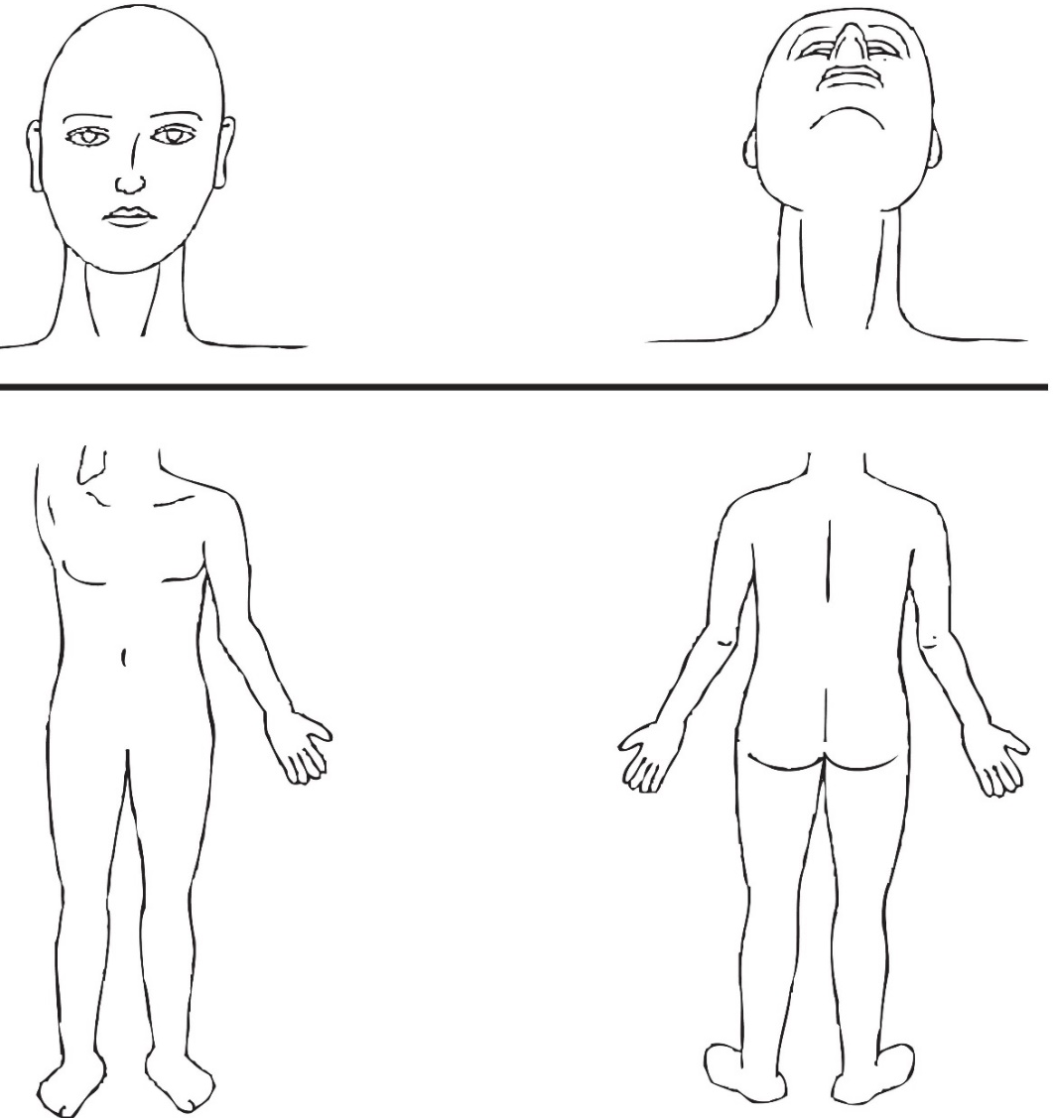
Area(s) to be treated: –  (detail where appropriate) | Cellulite deposits:
Area(s) to be treated: –  (detail where appropriate) | Fat deposits:
Area(s) to be treated: –  (detail where appropriate) | Body contour:
Area(s) to be treated: –  (detail where appropriate) | Skin laxity:
Pre-treatment photograph taken: | Yes | ☐ | No | ☐
Comments:

Treatment details – (including client reaction to treatment and treatment parameters):
Current intensity:
Duration of current flow:
Areas requiring modification:
Reaction levels:
Skin reaction to treatment:
Post-treatment photograph taken: | Yes | ☐ | No | ☐
Client feedback:
Post-care/Home care advice given:
Comments:

Pre-treatment consent and treatment information
The radio frequency treatment is designed to improve skin tone and texture and to improve body contours. During the treatment you may experience a gradual warming sensation and your skin may turn red. This will fade following treatment but you should tell your advanced non-medical aesthetic practitioner about the sensations you experience during treatment.

Immediately following treatment your skin may feel dry and tight. You may also experience mild erythema (redness) for 2-3 days.

Your active involvement before, during and after the treatment will establish the treatment outcome. It is vital that you adhere to the pre-treatment skincare regime and homecare protocols as instructed by your advanced non-medical aesthetic practitioner.

Client Name ___________________________________________________________________________________

Please initial those that apply:
_______ I have provided accurate medical information details to my advanced non-medical aesthetic practitioner.

_______ I am not pregnant or lactating.

_______ I do not have any active Herpes simplex (cold sores). Prophylactic antiviral medication or tropical antiviral cream may be used up to 2 days before treatment and up to 3 days after treatment.

_______ I agree not to receive any of the following on the treatment area 1 week prior to treatment – Botox, injectable dermal filers or needling treatments.

_______ I agree not to receive any of the following on the treatment area 2 week prior to treatment – bleaching, electrolysis, depilation, facial treatments using AHA/BHA/Vitamin A, Hair colouring, IPL/Laser for skin rejuvenation, IPL/Laser for hair removal, light therapy, microdermabrasion.

_______ I agree to avoid the use of any prescribed topical medications i.e. Retin A, Salicylic Acid a minimum of 2 weeks prior to treatment.

_______ I agree to avoid the use of active skin care 3-5 days prior to treatment.

_______ I confirm that I have not used Isotretinoin in the past 6 months.

_______ I agree to follow the treatment protocol advised by my advanced non-medical aesthetic practitioner prior to treatment.

_______ I agree to avoid direct sun exposure.

_______ I agree to apply a sunscreen daily (minimum SPF30).

_______ I agree to avoid any heat treatment immediately prior to treatment.

_______ I agree to notify my advanced non-medical aesthetic practitioner of any concerns.

_______ I understand that the following contra-actions may occur:
- Allergic reaction | - Erythema (redness) | - Itching/irritation
- Blistering | - Excessive oedema | - Hyper-pigmentation
- Bruising | - Excessive pain | - Scarring
- Burns

_______ I understand that thermal/tactile tests must be performed in order to ascertain my levels of sensitivity.

_______ I understand that a patch test must be performed where there is the possibility of an allergy and when treatment products are changed.

_______ I understand that treatment results are varied and not guaranteed.

_______ I have discussed my expectations and goals with my advanced non-medical aesthetic practitioner.

_______ I have discussed the treatment limitations and possible complications with my advanced non-medical aesthetic practitioner.

_______ I acknowledge the possibility of an adverse reaction to treatment and take sole responsibility for any medical care that may become necessary. I agree to immediately inform the practitioner performing the treatment of any adverse effects.

_______ My advanced non-medical aesthetic practitioner has provided treatment information and answered all of the questions I have concerning this treatment.

_______ I fully understand all of the above information.

Client name: ____________________________________________________________________________________

Client signature: _________________________________________________________________________________

Advanced non-medical aesthetic practitioner name: ____________________________________________________

Advanced non-medical aesthetic practitioner signature: _________________________________________________

Date: ______________________________

Photographs of your skin are taken before, during and after treatment to monitor and document progress.
I hereby authorise _____________________________ to take photographs of me before, during and after my treatment series.
Client signature: _______________________________ Date: ___________________

Photographs are useful tools for educating others about conditions such as your own.
I hereby authorise __________________________ to use or show my photographs for the purpose of education.
Client signature: ____________________________ Date: ______________________

Post-treatment instructions
In order to achieve the best results possible it is important that you read and understand the following instructions. Your advanced non-medical aesthetic practitioner will discuss the required post-treatment protocols with you following treatment; these instructions must be adhered to as advised by your advanced non-medical aesthetic practitioner.
- Your advanced non-medical aesthetic practitioner will advise you of the expected treatment recovery time and skin response.
- Avoid additional heat treatment such as saunas, steam rooms, sun beds etc. for 48 hours as excess heat can lead to discomfort, inflammation and irritation.
- Immediately following treatment it is essential that you apply a broad spectrum physical sunscreen (minimum SPF30). This must be reapplied according to manufacturer’s instructions.
- Avoid direct sun exposure for 48 hours following treatment.
- Avoid strenuous/excessive exercise for 24 hours to prevent overheating/increased blood circulation.
- Increase water intake to at least 2 litres per day.
- Avoid the use of glycolic acid, retinol, AHA/BHA products for at least 24-48 hours.
- Use post-treatment products as instructed by your advanced non-medical aesthetic practitioner.
- Your advanced non-medical aesthetic practitioner will advise you of ongoing treatment recommendations and suitable treatments which may be used in conjunction with radio frequency treatment.

Additional information:

I accept the results of the treatment performed today and I understand and agree to adhere to the above instructions. I agree to contact my advanced non-medical aesthetic practitioner with any additional questions I may have.

Client name: _______________________________________________________________________________

Client signature: ________________________________________________ Date: _______________________

Advanced non-medical aesthetic practitioner name: _______________________________________________

Advanced non-medical aesthetic practitioner signature: __________________________ Date: ____________

Lecturer name: _____________________________________________________________________________

Lecturer signature: ______________________________________________ Date: _______________________

Skin Sensitivity/Patch Test

Client information
Please read carefully and only sign if you are in full agreement with its contents.

I _____________________ confirm that I have received the required skin sensitivity/patch test(s) 24-48 prior to radio frequency treatment and confirm that I am willing to proceed.

You should note that if the learner is unable to explain to you the treatment contra-actions and contra-indications or is unsure of anything that may apply to a specific condition then they should not treat you without asking you to consult with your GP or Consultant.

It is your responsibility and not that of the learner to consult your GP or Consultant.

I hereby indemnify the learner against any adverse reaction sustained as a result of the treatment.

Client signature: _____________________________________ Date: _____________________

Learner signature: ____________________________________ Date: _____________________

